**Lab Exercise 4**

**Setting up Poll SCM Configuration in Jenkins**

Step 1: Log in to the Jenkins CI tool and set up poll SCM configuration

1.1 Log in to Jenkins using the credentials

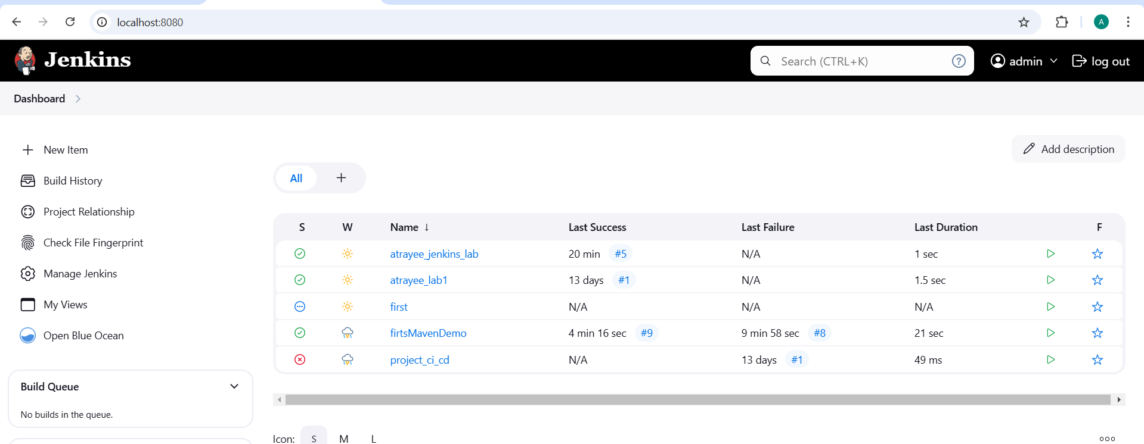

1.2 In the Jenkins dashboard, click on New Item

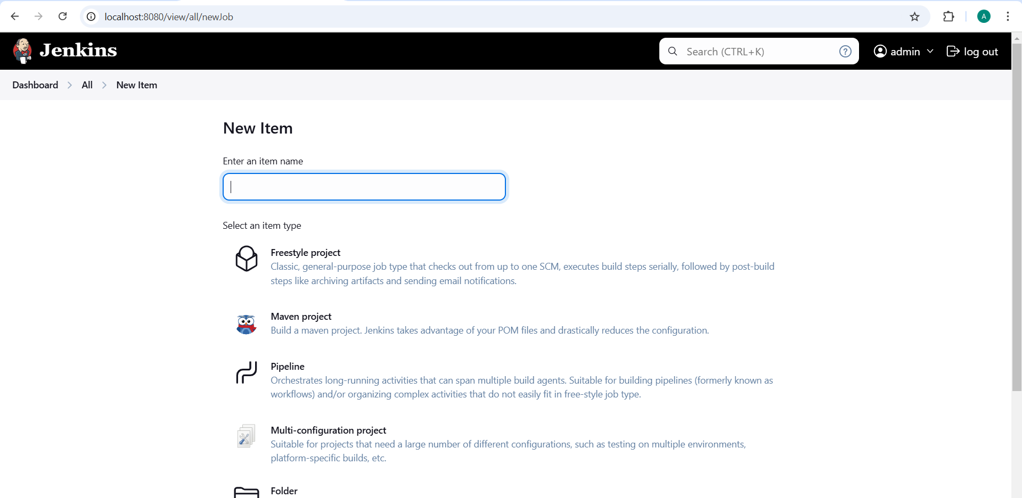

1.3 Select the Freestyle project while creating a Jenkins job, provide a custom job name, and click on OK

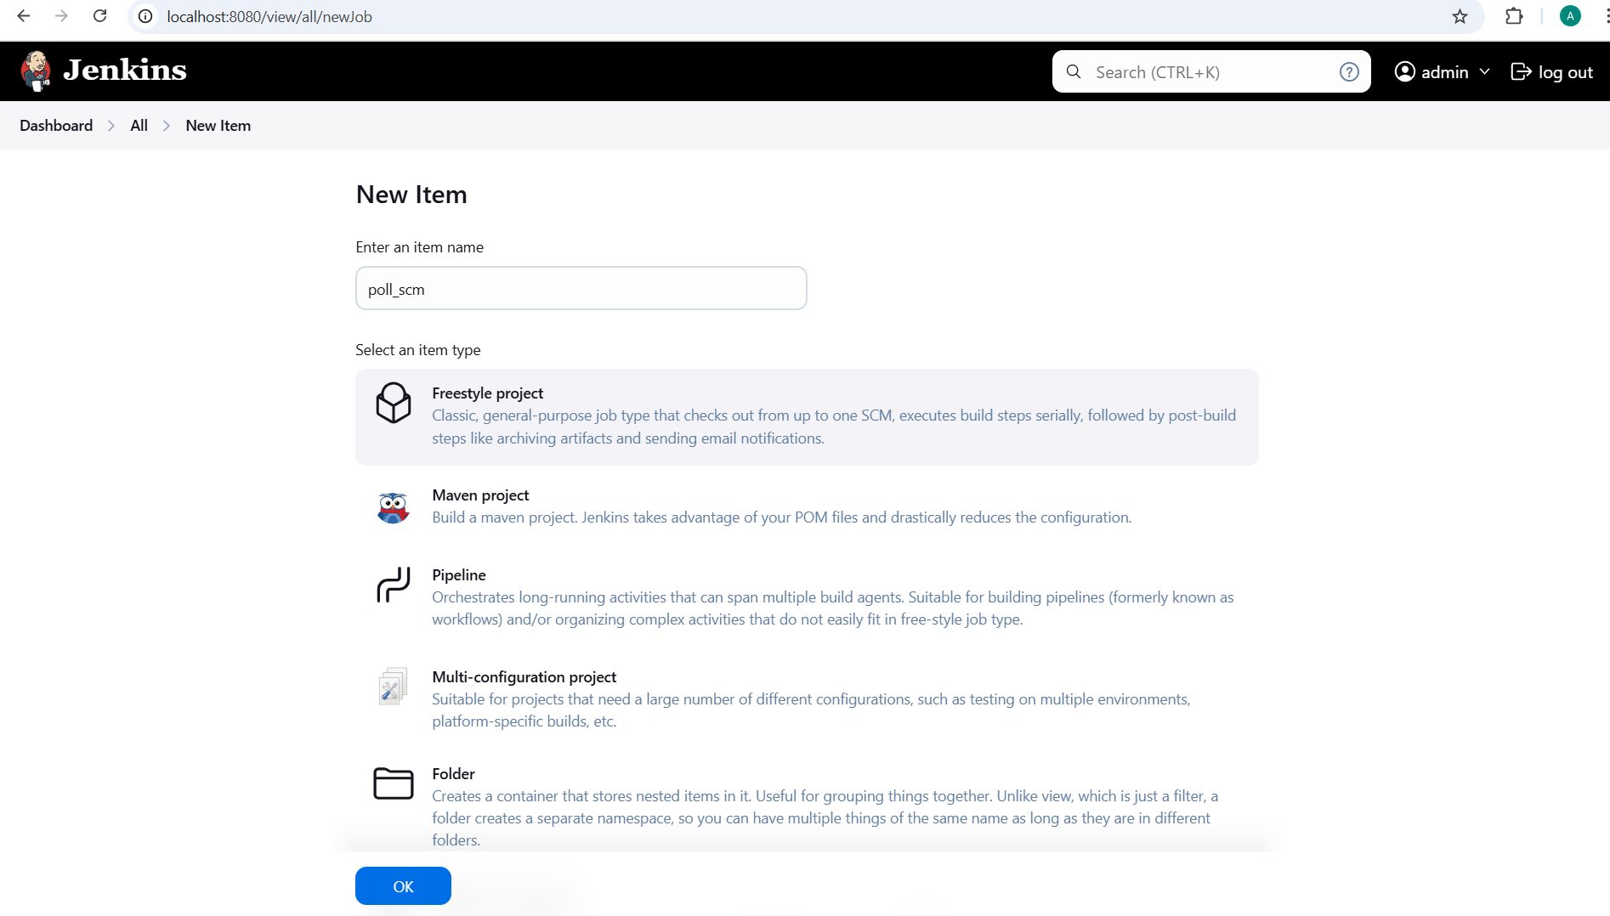

1.4 Now, in the Configure page, navigate to Source Code Management from the left navigation bar, select Git, and then provide the Git repository URL

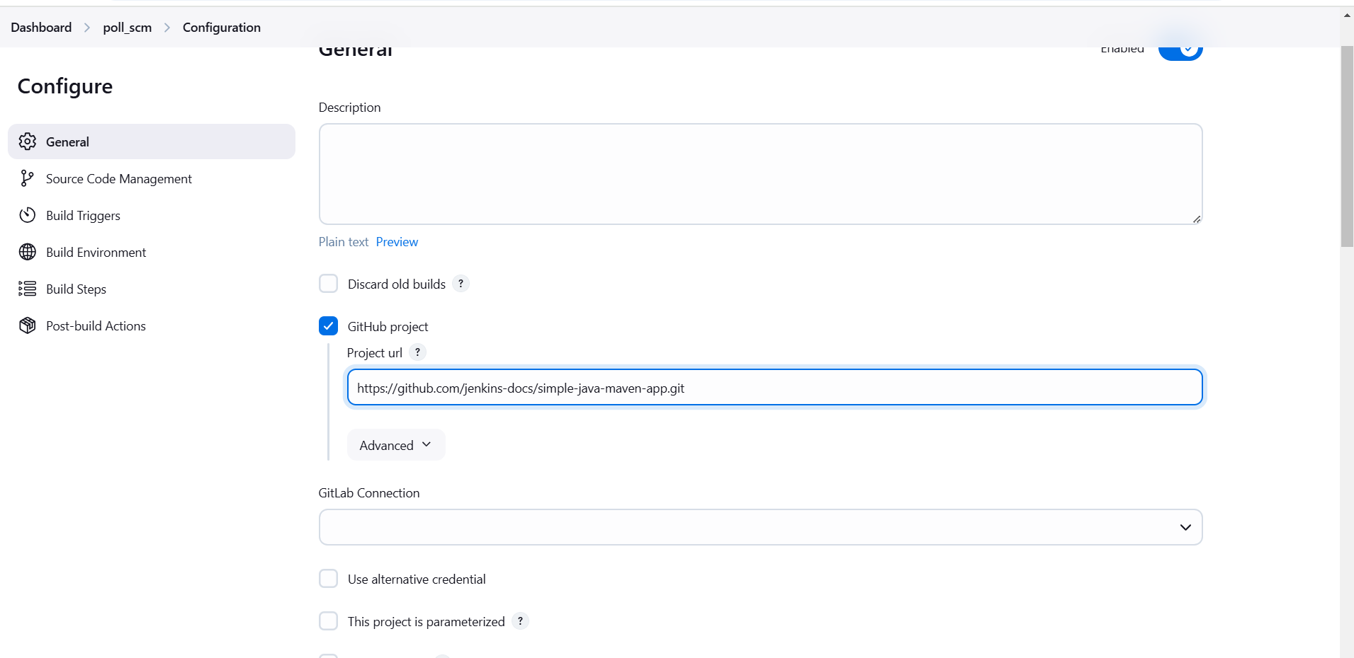

1.5 Now, navigate to Build Environment, click on Poll SCM, provide H/2**** under the Schedule section, and then click on Save

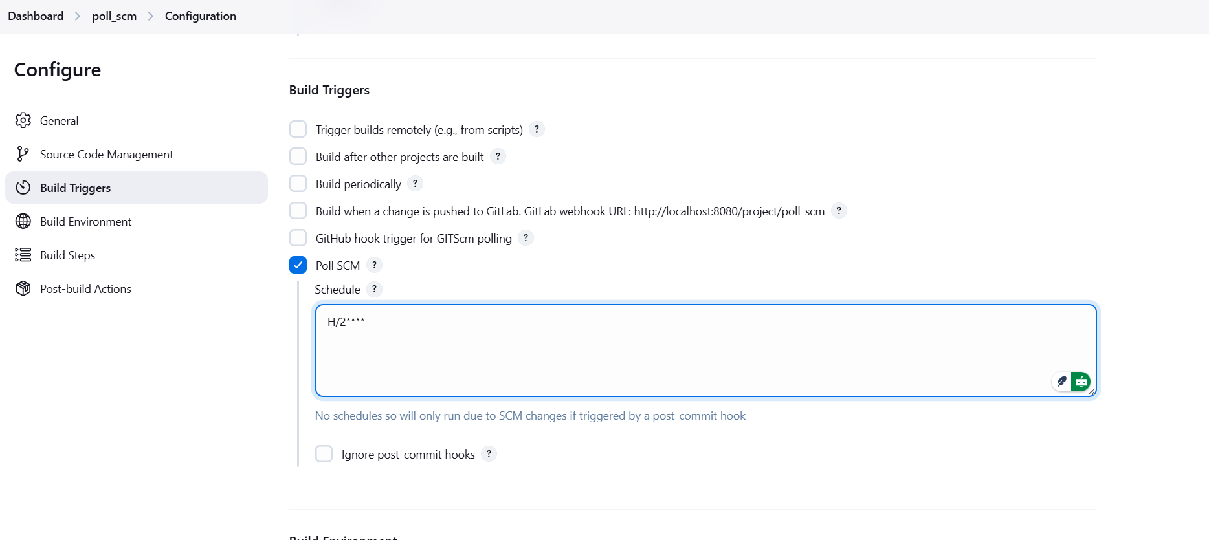

1.6 You will be directed to the poll scm project after clicking on Save. Now, click on Git Polling Log from the left navigation bar.

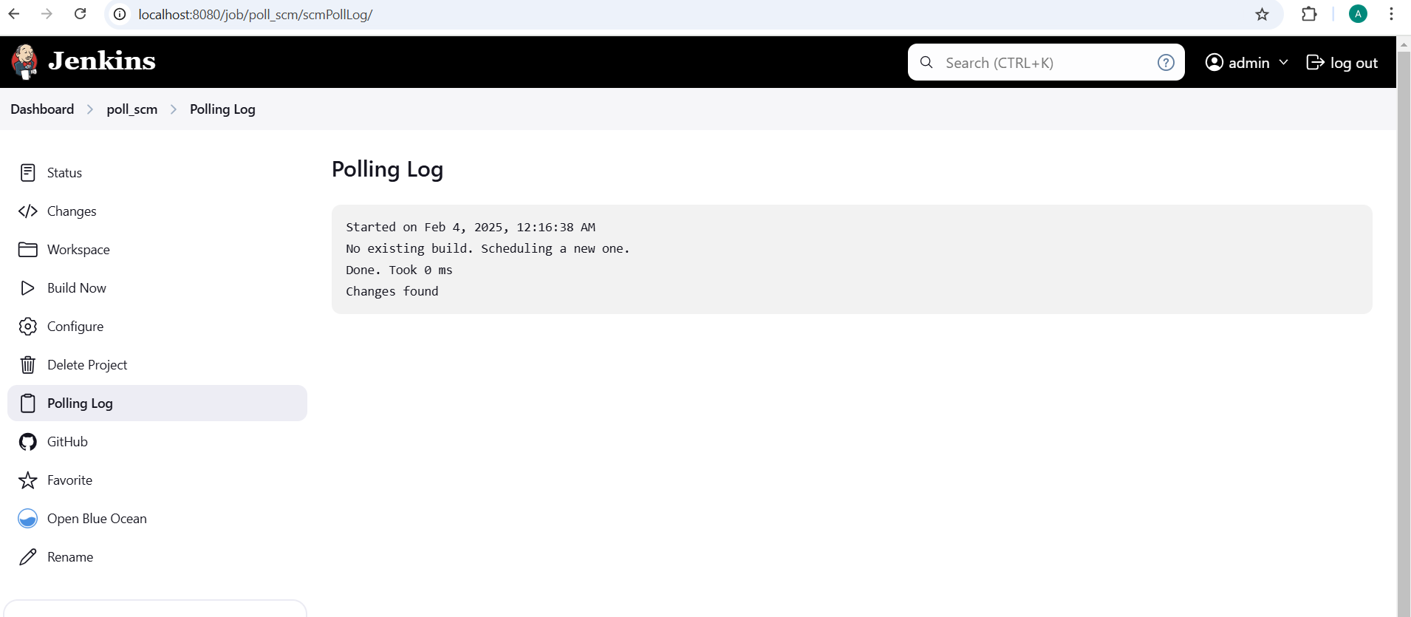

1.7 Then, click on Build Now to configure a build, and you will be able to view the successful build in the Console output section.

